**Ex.No : 4**

**Date : 14/10/2020**

**Aim:**

To write a python program to print a single string from two set of strings and swap the first two characters of each string.

**Program:**

def swap(c,z):

a=c[:2]+z[2:]

b=z[:2]+c[2:]

return b+''+a

x=str(input()).strip()

y=str(input()).strip()

if(len(x)<2 or len(y)<2):

print("Invalid")

else:

f=swap(x,y)

print(f)

**Output:** 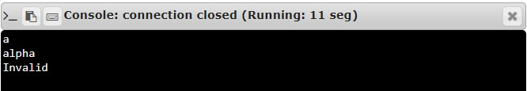

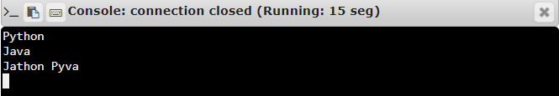

**Result:**

Thus, the program to swap first 2 character of 2 words is created and required output is executed.